# Arduino core for the ESP32

## Contents

* [Development Status](https://github.com/espressif/arduino-esp32#development-status)
* [Installation Instructions](https://github.com/espressif/arduino-esp32#installation-instructions)
* [Decoding Exceptions](https://github.com/espressif/arduino-esp32#decoding-exceptions)
* [Issue/Bug report template](https://github.com/espressif/arduino-esp32#issuebug-report-template)
* [ESP32Dev Board PINMAP](https://github.com/espressif/arduino-esp32#esp32dev-board-pinmap)

### Development Status

[Latest stable release](https://github.com/espressif/arduino-esp32/releases/latest/)

[Latest development release](https://github.com/espressif/arduino-esp32/releases/latest/)

### Installation Instructions

* Using Arduino IDE Boards Manager (preferred)
  + [Instructions for Boards Manager](https://github.com/espressif/arduino-esp32/blob/master/docs/arduino-ide/boards_manager.md)
* Using Arduino IDE with the development repository
  + [Instructions for Windows](https://github.com/espressif/arduino-esp32/blob/master/docs/arduino-ide/windows.md)
  + [Instructions for Mac](https://github.com/espressif/arduino-esp32/blob/master/docs/arduino-ide/mac.md)
  + [Instructions for Debian/Ubuntu Linux](https://github.com/espressif/arduino-esp32/blob/master/docs/arduino-ide/debian_ubuntu.md)
  + [Instructions for Fedora](https://github.com/espressif/arduino-esp32/blob/master/docs/arduino-ide/fedora.md)
  + [Instructions for openSUSE](https://github.com/espressif/arduino-esp32/blob/master/docs/arduino-ide/opensuse.md)
* [Using PlatformIO](https://github.com/espressif/arduino-esp32/blob/master/docs/platformio.md)
* [Building with make](https://github.com/espressif/arduino-esp32/blob/master/docs/make.md)
* [Using as ESP-IDF component](https://github.com/espressif/arduino-esp32/blob/master/docs/esp-idf_component.md)
* [Using OTAWebUpdater](https://github.com/espressif/arduino-esp32/blob/master/docs/OTAWebUpdate/OTAWebUpdate.md)

### Decoding exceptions

You can use [EspExceptionDecoder](https://github.com/me-no-dev/EspExceptionDecoder) to get meaningful call trace.

### Issue/Bug report template

Before reporting an issue, make sure you've searched for similar one that was already created. Also make sure to go through all the issues labelled as [for reference](https://github.com/espressif/arduino-esp32/issues?utf8=%E2%9C%93&q=is%3Aissue%20label%3A%22for%20reference%22%20).

Finally, if you are sure no one else had the issue, follow the [ISSUE_TEMPLATE](https://github.com/espressif/arduino-esp32/blob/master/docs/ISSUE_TEMPLATE.md) while reporting any issue.

### ESP32Dev Board PINMAP

[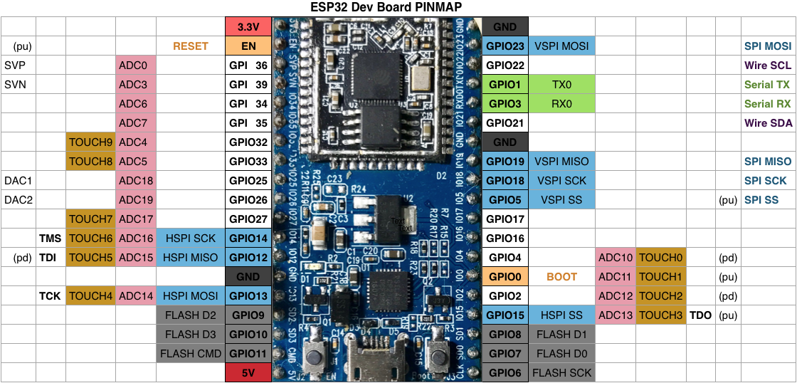](https://github.com/espressif/arduino-esp32/blob/master/docs/esp32_pinmap.png)

### Tip

Sometimes to program ESP32 via serial you must keep GPIO0 LOW during the programming process

**Installation instructions using Arduino IDE Boards Manager**

* Stable release link: https://raw.githubusercontent.com/espressif/arduino-esp32/gh-pages/package_esp32_index.json
* Development release link: https://raw.githubusercontent.com/espressif/arduino-esp32/gh-pages/package_esp32_dev_index.json

Starting with 1.6.4, Arduino allows installation of third-party platform packages using Boards Manager. We have packages available for Windows, Mac OS, and Linux (32, 64 bit and ARM).

* Install the current upstream Arduino IDE at the 1.8 level or later. The current version is at the [Arduino website](http://www.arduino.cc/en/main/software).
* Start Arduino and open Preferences window.
* Enter one of the release links above into *Additional Board Manager URLs* field. You can add multiple URLs, separating them with commas.
* Open Boards Manager from Tools > Board menu and install *esp32* platform (and don't forget to select your ESP32 board from Tools > Board menu after installation).